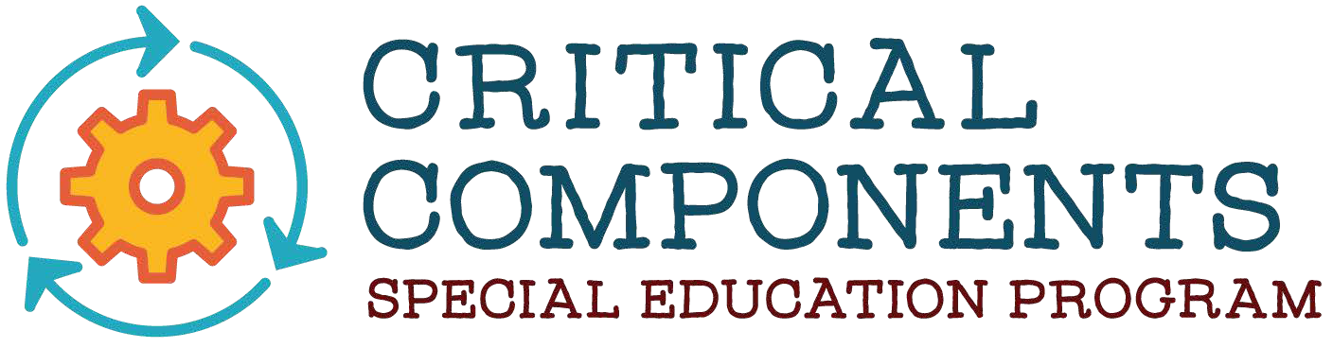

CRITICAL COMPONENTS OF SPECIAL EDUCATION PROGRAMS CHECKLIST

Date:

Team Members:

Purpose:
The Illinois State Board of Education has stated that “in successful districts and schools, there is a collective commitment to collaboratively identify, plan, implement, monitor, evaluate, and communicate changes necessary to continuously improve student learning for all students.”
Further, it is essential to ensure that students with IEP’s have opportunities to benefit from high-quality instruction, to reach the same standards as all students, and to leave school prepared to successfully transition to post-school learning, living, and working. The Critical Components Tool for Special Education Programs was developed as a result of an extensive literature review to assist school leaders in facilitating conversations, reviewing, and improving the quality of special education programs, services, and supports as a key component of continuous improvement efforts as both the District/Cooperative/School level.
The Critical Components Tool for Special Education Programs (Critical Components Tool) offers guidance to educators and administrators when developing, implementing, and evaluating quality programs and services for students with IEP’s. The Critical Components Tool identifies twelve domains to consider for effective programs. Under each domain is an indicator and below that are descriptors of the indicator that define quality school experiences with the goal of improving post-school outcomes for all students with IEP’s. The Critical Components Tool is designed to assist Districts/ Cooperatives/ Schools to review practice and to identify and act on areas where improvement is desired or needed and should not be interpreted as policy or regulation.
The Critical Components Tool is meant to be used in conjunction with a continuous District/ Cooperative/ School improvement process that reviews multiple measures including a variety of data and other assessment tools. It can be utilized in conjunction with the Illinois Quality Framework as a companion tool to look deeper into the area of special education and special education programming. The team may choose to complete the Critical Components Tool in its entirety, select specific domains on which to focus, or complete the screener. Action plans resulting from this analysis should be integrated with the District/ Cooperative/ School improvement plan.
In summary, the purpose of the Critical Components Tool for Special Education Programs is to assist Districts/ Cooperatives/ Schools with the following goals:
- Identify a site’s current implementation level (baseline analysis)
- Identify areas that are effective and those in need of improvement
- Support the development of goals and action planning in critical areas of special education programming

Instructions for Administration:
Identify a team to complete The Critical Components Tool for Special Education Programs. This team should include a variety of stakeholder representative of both general and special education (e.g. administrators, teachers, support personnel, parents, students, a school board member etc.). This team could be an existing District/Cooperative/School leadership team, or an ad hoc team developed for this specific purpose.
Prior to meeting as a team, each team member must review the Critical Components Tool and independently rate each item on their copy of the Critical Components Tool. It should then be submitted to the facilitator for aggregating the scores identifying areas of agreement and disagreement. Each team member should think about evidence which would support their rating. Should an item not be used within the District/Cooperative/School, the team member and team should insert N/A in the evidence column the Critical Components Tool.
After each member has reviewed the Critical Components Tool independently, schedule approximately one to two hours to meet as a team to discuss individual responses and reach agreement on the rating that best represents the current status of implementation at the identified site. A team member should be identified as the notetaker to record the ratings for each item, supporting evidence, and team discussion. A facilitator to support administration of the Critical Components Tool should also be identified.
Complete the Critical Components Tool. The facilitator will identify each item and ask team members to indicate their individual rating by a show of fingers. (Not implementing = 0, Emerging = 1, Implementing = 2, Exemplary = 3) If everyone is in agreement, the notetaker will record that rating. If team members have varying responses, discussion will be held until a consensus regarding the rating is reached. Discussion will be documented in the notes section. Record evidence supporting the ratings of “Implementing” and “Exemplary” only.
Use the completed Critical Components Tool for Special Education Programs to analyze the results, identify areas of strength, and challenge. Prioritize areas of challenge and select items for further analysis and/or action planning. Develop goals to improve identified areas. Goals and action planning from your review should be integrated with the District/Cooperative/School improvement plan.

Rubric for Evaluation:
The following definitions describe each rating utilized on the Critical Components of Special Education Programs Checklist:

Not Implementing (0) | No evidence of implementation
Emerging (1) | Inconsistent evidence of implementation
Implementing (2) | Implementation is occurring but requires ongoing support, professional  learning, and/or further development
Exemplary (3) | Implementation is occurring consistently in all settings without support and is a part of the district/school culture

CRITICAL COMPONENTS OF SPECIAL EDUCATION PROGRAMS CHECKLIST

X. EDUCATOR QUALITY
Indicator and Descriptors
10. The District/School employs highly qualified, licensed special  education personnel that demonstrate expertise in working with students with IEPs. | Not Implementing | Emerging | Implementing | Exemplary | Evidence
a. Staff hold full credentials/licensure and advanced degrees in content
areas.
b. Staff roles and responsibilities are clearly defined and implemented.
c. All staff working with students with IEPs are knowledgeable about their responsibilities in implementing the individualized education programs
(IEPs).
d. Staff collaborate with specialized instructional support personnel as specified in a student’s IEP or as needed.
e. All staff working with students with IEPs share and communicate common
instructional outcomes.
f. There are systems in place that provide para-educators with instructional plans, training, and the necessary information to successfully support students with IEPs(e.g., disability specific, IEP goals and objectives,
adaptations).
g. Fading para-educator support is pre-planned and outlined in a student’s IEP.
h. All staff involved with students are trained in nonviolent crisis
intervention techniques and district/school policy forthe use of restraint and time out including the reporting procedure.

TEAM DISCUSSION NOTES

EDUCATOR QUALITY
The District/School employs highly qualified, licensed special education personnel that demonstrate expertise in working with students with IEPs.

